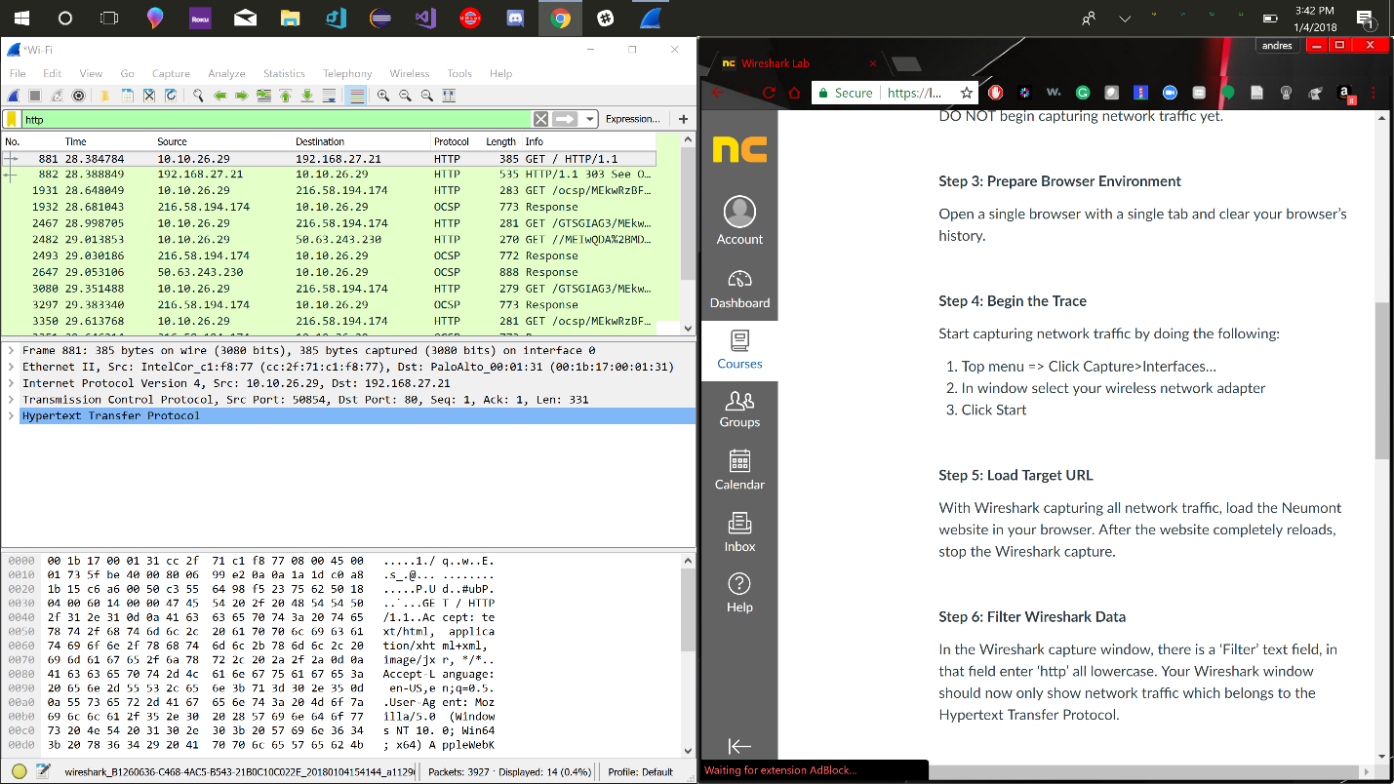Andres Hermilo Carrera Reynaga

What version of the internet protocol is being used?

V1.1

What is the IP address of your computer?

192. 168. 27. 21

What is the IP address of the server?

10.10.26.29

What port is your browser using to communicate with the server?

80

What port is the server responding to requests on?

50854

What is the definition of a TCP ‘Sequence Number’?

A number to specify where in the stream the packet is.

What is the definition of a TCP ‘Acknowledgement Number’?

A number signifying the number of bytes received.

What version of HTTP is your browser running?

V1.1

What is the host name being called?

[www.neumont.edu](http://www.neumont.edu)